Project Name – Wanderlust Airlines



presented By: presented to:
Harpreet Singh mohemad Karim weslati
Ashish Sharma
Gurbhej Singh
Gurkirat Sigh
Avneet Kaur
Description:
Name of Website:WanderLust Airways
About:Flight booking .
Home:In the home section ,we include destinations about where we can book tickets and
we also have interface by which we book ticket.
Log in:in this section validation is done for log in if username and password are wrong
then pop up apear that shows about error while log in
log out:this section only pop up when the user log in otherwise this section is being hidden,
after click on logout all session values are clear.
profile:this section includes the details about the user,in this section we can edit the
personal detail of the user.
Validation:Every field are validated to minimum requirements

Technologies Used -
- HTML+CSS
- Bootstrap
- PHP
- Database - MSql

Use Case Diagram -
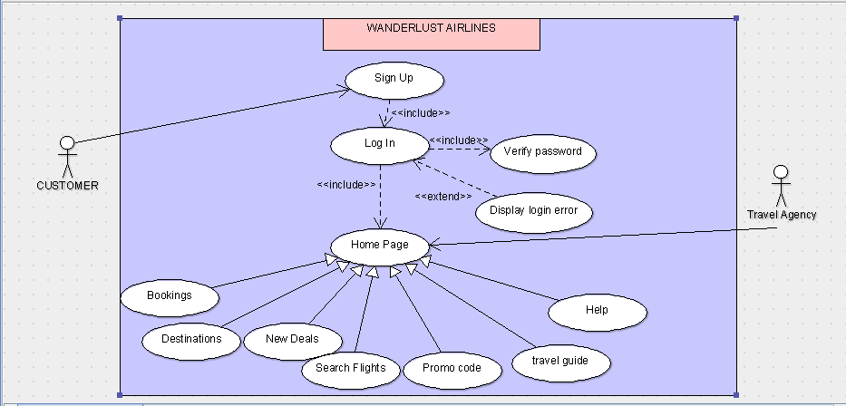

Class Diagram -

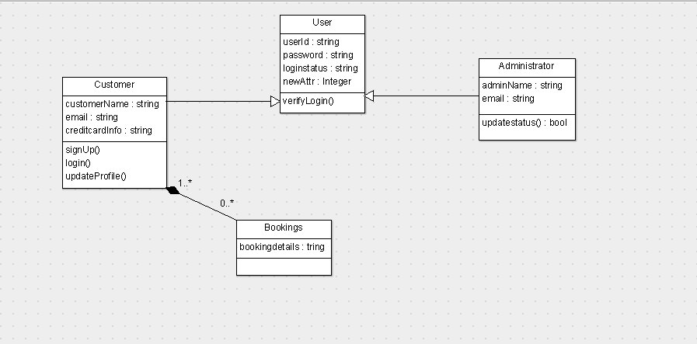

Activity Diagram -
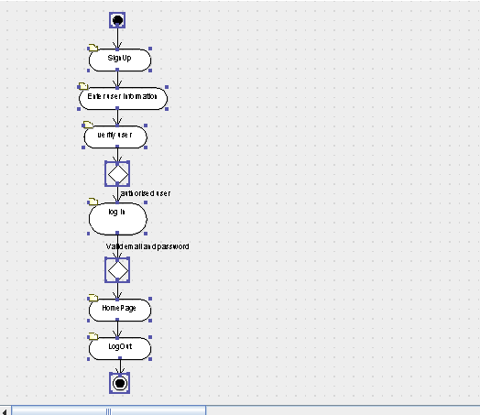

Features –
- Home Page -
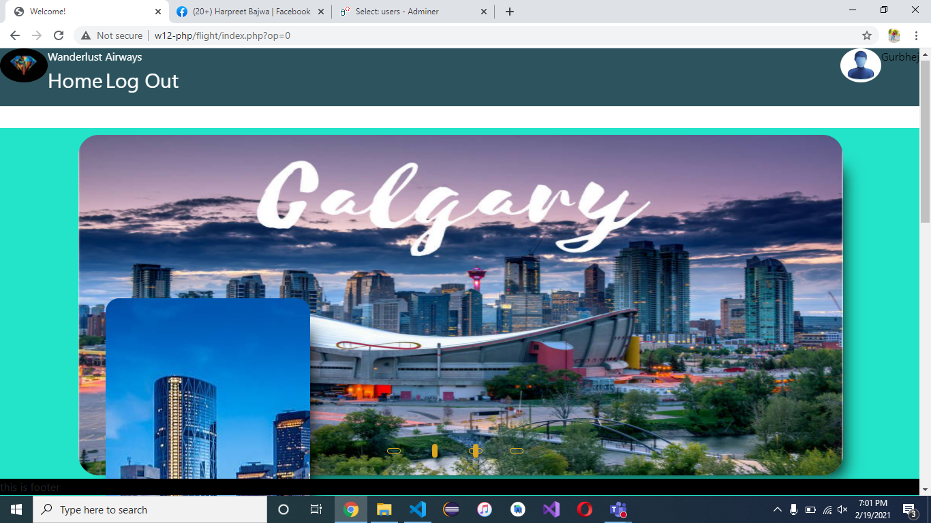
- Sign Up

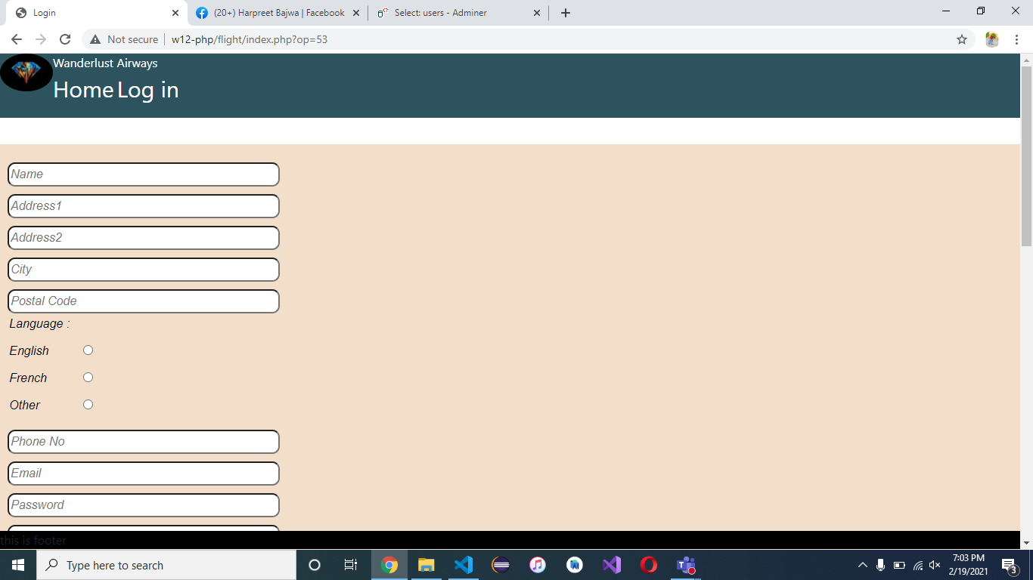

- Login
